About Us Our Brand Operation our customers last news

About Us
Hamad Saleh Al Homaizi Grandsons Pharma. Co., with its FMCG affiliate H.S.H.G united trading & contracting company, is a private business owned by Mr. Hamad & Saleh Alghanim, based in the State of Kuwait, that continues to be the home of World’s largest, most advanced medical, nutritional, and FMCG manufactures. During past 50 years, the establishment gradually developed into a full-fledged company that today represents 30 international agencies with over 2,000 products, with a manpower of 250 employees.
Mission & Vision
Mission
Building professional team, innovative, responsible to convert challenges into opportunities



Dddd DNA About Al Homizi Group Fadel & May to Provide Material
Agile
Dependable
We Are All
Nearby
Vision
Serving delight & healthy life, every day, everywhere with iconic brands and Value products

Our Brand

Snakes Max Sport-TBN-Hampton harvest- Mario will provide the material
Beverage Vitaday-Byblos-Frugo
Dry Food Maeda - Pasta
Cosmetics Bigen-
Body care TITANIA- FASHY
OTC Adol-Mebo-Cawells-clofen- (and other Julghar brand after permeation from Julghar)
Everyday KODAK battery – KODAK Razor – KODAK LED light

Operation
Sales & Distribution Fadel will provide we material
Supply Chain
Merchandising
Direct sales Distribution

Our customers Fadel will provide material

Operation

Sales & Distribution

We at HSHG believe in specialization and the importance of understanding the needs of the client, so we follow the strategy of distribution lines, follow-up and development based on sales channels, where understanding each sales channel secures challenges and practical solutions for each sales force

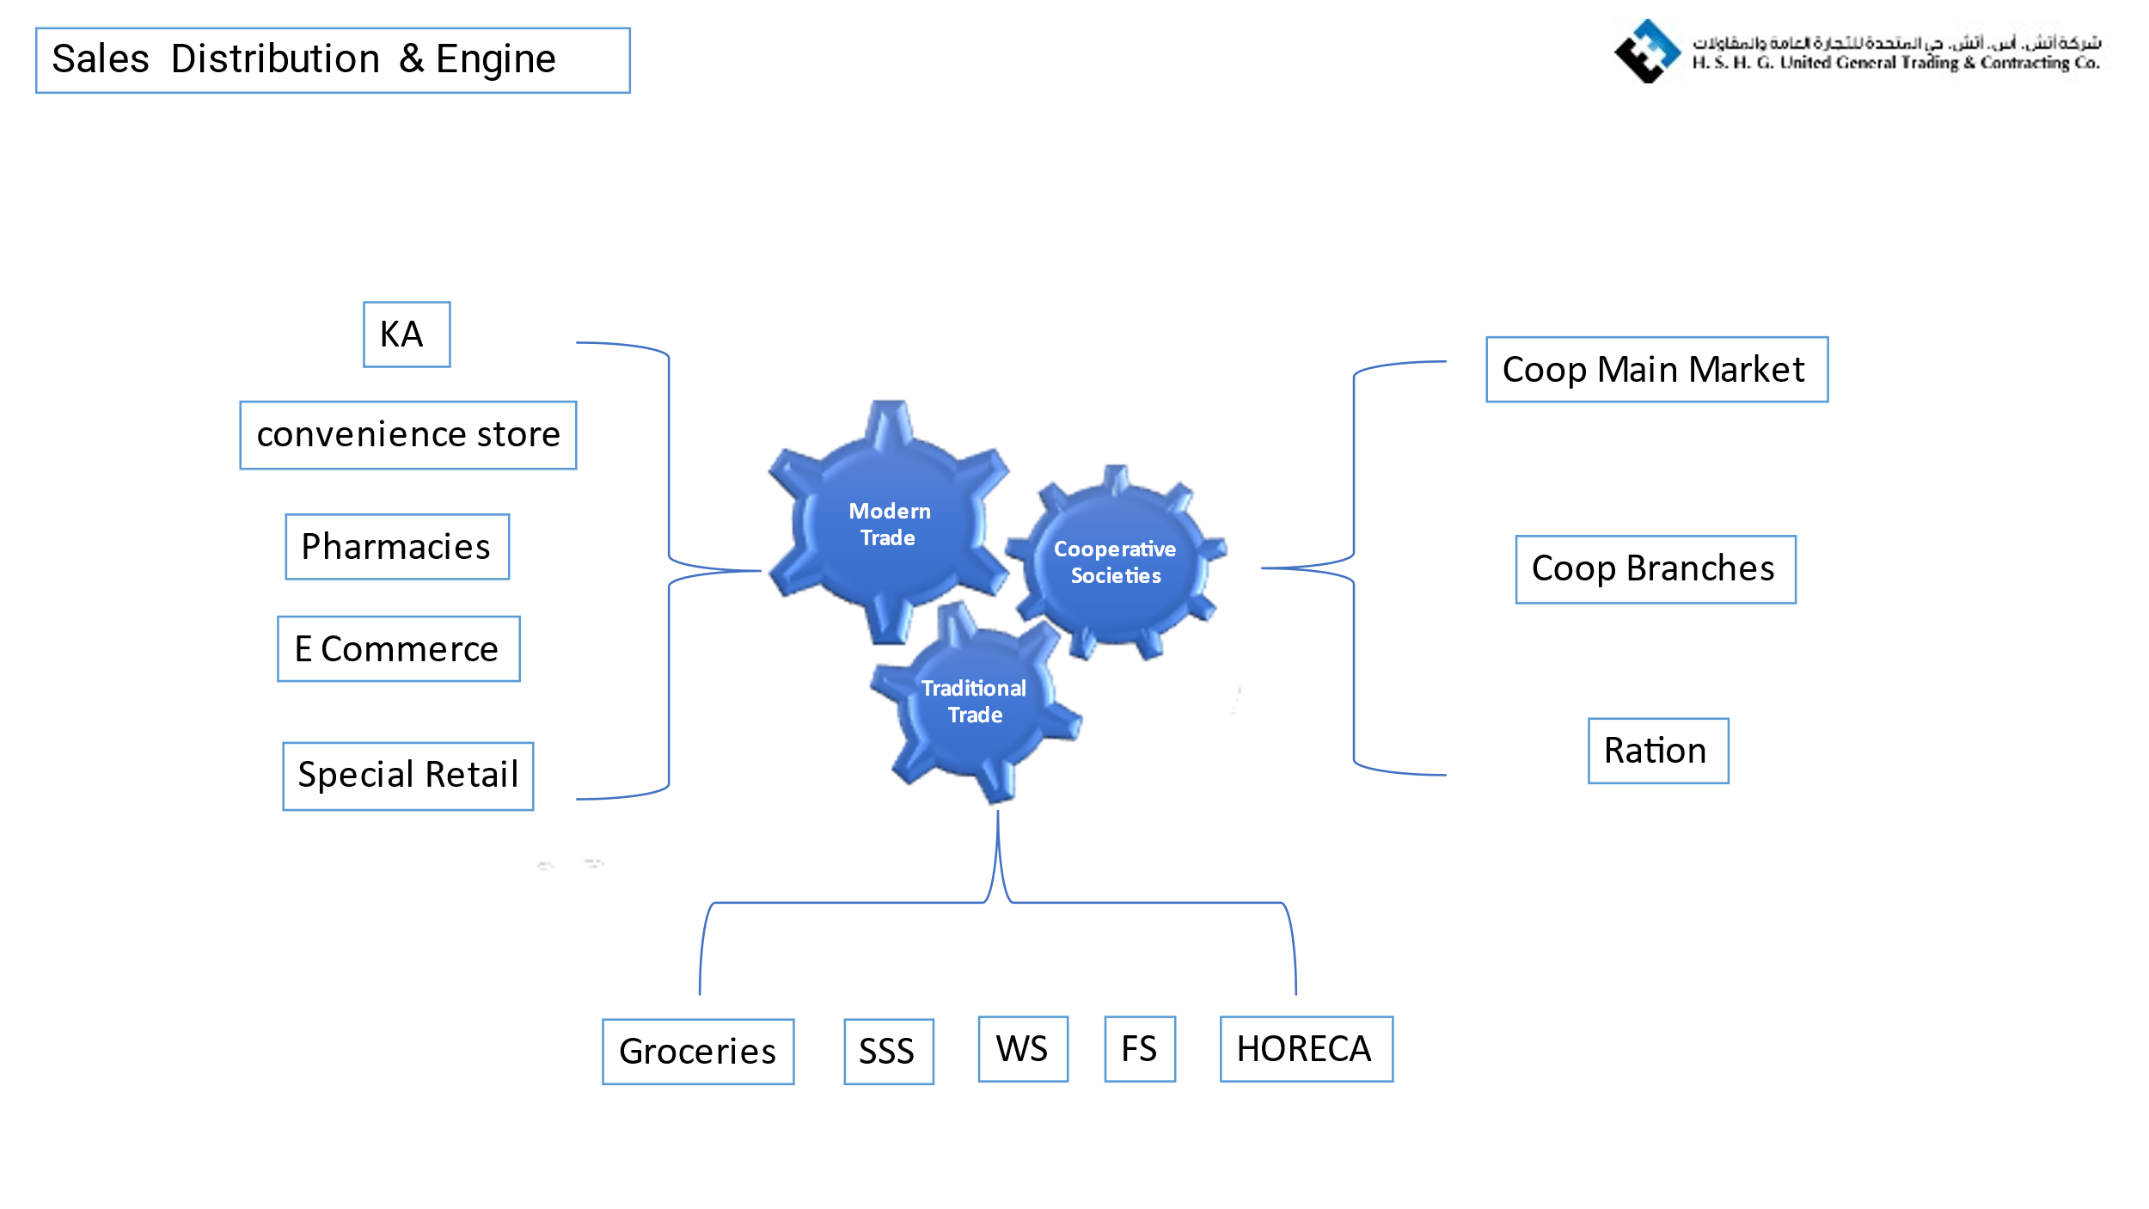

Supply Chain
Supply Chain & Warehousing Capabilities With efficient warehousing and distribution facilities supported by ERP systems, HSHG is committed to providing our customers with the best service levels. Our facility has the size and features to meet all FMCG requirements. You name it, we have it Our well-trained staff, with many years of FMCG experience are experts in handling food and non-food and medicine items across several temperature zones.10,000 CBM of temperature controlled warehouse space.16 fleet of temperature controlled trucks and vans which can service all channels of customers across Kuwait, .Taking help from our partner companies, we ensure efficient shipment tracking and in-transit handling of various types of consignments from different parts of the world, enabling us to excel in speed to market.

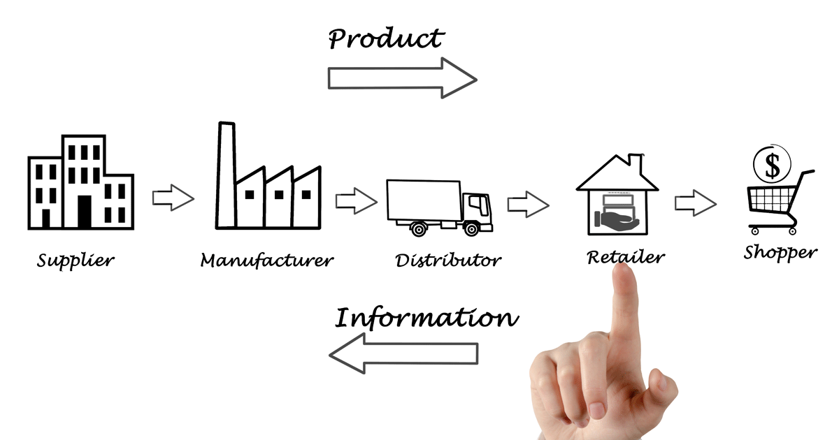

Merchandising

As sales & Distribution has been divided in Sales channel wise, Merchandisers Team also has been splatted in on same concept, to insure of excellent service for the products and sales outlets, with ensure that team had full products knowledge and the tools to do job in perfect way

Direct sales Distribution

in Order to ensure our partners Brand are available in many customers as possible, we establish DSD operation Direct sales distribution. Via this model of operation, we target to reach more than 2000 point of sales in Kuwait state.

